Scenario 1: Check that url endpoint starts with https (Secured)  PASS  
Actual outcome- [https://seun-akinbode-2022-09-29.cookieclickertechtest.airelogic.com/](https://urldefense.com/v3/__https:/seun-akinbode-2022-09-29.cookieclickertechtest.airelogic.com/__;!!K-t5rA0NaMnkAg!XPFD-kl9wuiAYnOOORpgX_F0q4SRdUQf9wZCj28Ei7cdQTCgJGz82vRF0zNslcErDm5uM941d5E1ADnhXj1z2M6WFqCaNFu1$)  
Expected outcome- [https://seun-akinbode-2022-09-29.cookieclickertechtest.airelogic.com/](https://urldefense.com/v3/__https:/seun-akinbode-2022-09-29.cookieclickertechtest.airelogic.com/__;!!K-t5rA0NaMnkAg!XPFD-kl9wuiAYnOOORpgX_F0q4SRdUQf9wZCj28Ei7cdQTCgJGz82vRF0zNslcErDm5uM941d5E1ADnhXj1z2M6WFqCaNFu1$)  
  
  
  
  
Scenario 2: Validate that customer can input valid names into the name input box  
Given i navigate to the Cookie Clicker website  
When i input Seun O'Connor into the name input box  
And click on start button  
Then i am redirected to the Second page (Actual outcome)  
Redirected to the Second page (Expected outcome) PASS  
  
Scenario 3: Validate that invalid names input is not allowed into name box  
Given i navigate to the Cookie Clicker website  
When i input %%seu4 --a4kinb+ into the name input box  
And click on start button  
Then i am redirected to the Second page(Actual outcome)  
Invalid data(numbers,special characters %) should not be allowed for input (Expected outcome) Fail  
  
Scenario 4: Validate that Customer name is shown on the Cookies page  
Given i navigate to the Cookie Clicker website  
And input Seun O'Connor in the name input box  
When i click on the start button  
Then 'Hello Seun O'Connor' is shown on the Second page(Actual outcome)  
Hello with name Seun O'Connor should be shown (Expected Outcome)PASS  
  
Scenario 5: Validate that the amount of clicking the 'Click Cookie!'button reflects in the cookies numbers  
Given i navigate to the Cookie Clicker website  
And input Nelson Mandela  in the name input box  
And i click on the start button   
When i click the 'Click Cookie!' button 3 times  
Then Cookies section at top has 3 in front of it (Actual outcome)  
Cookies section at top has 3 in front of it (Expected outcome)  
  
  
Scenario 6: Validate that 'Sell Cookies!' button is functional  
Given i navigate to the Cookie Clicker website  
And input Boris Johnson  in the name input box  
And i click on the start button   
And i click the 'Click Cookie!' button 3 times  
And input 1 into the 'Sell Cookies!' input box  
When i click 'Sell Cookies!' button  
Then number of Cookies at the top is reduced to 2   
And Money is increased from 0 to $0.25 (Actual outcome)  
number of Cookies at the top is reduced to 2 (Expected outcome)  
And Money is increased from 0 to $0.25 (Expected outcome) PASS  
  
Scenario 7: Validate that 'Buy Factories!' button is functional  
Given i navigate to the Cookie Clicker website  
And input Boris Johnson  in the name input box  
And i click on the start button   
And input 1 into the 'Buy Factories!' input box  
When i click 'Buy Factories!' button  
Then Factories number is increased to 1 (Actual outcome)  
Factories number is increased to 1 (Expected  outcome)PASS  
  
Scenario 8: Validate clicking the Cookie Clicker link at top of 2nd page redirects to homepage  
Given i navigate to the Cookie Clicker website  
And input John stones  in the name input box  
And i click on the start button  
When i click on 'Cookie Clicker!' at top of page  
Then i am redirected to homepage(Actual outcome)  
redirected to homepage(Expected  outcome)PASS  
  
Scenario 9: Validate that Player account/score is shown on the homepage after action on the 2nd page  
Given i navigate to the Cookie Clicker website  
And input Jacki digan  in the name input box  
And i click on the start button  
And input 1 into the 'Buy Factories!' input box  
And I click 'Buy Factories!' button   
When i click on back navigation button   
And i am redirected to homepage  
Then Jacki digan is not shown in the player/score section/ Name shown only after refreshing page(Actual outcome)  
Jacki digan should be shown in the player/score section after redirecting(Expected outcome)FAIL  (BUG)  
  
  
  
  
  
   
  
  
Bugs from Exploratory testing  
  
BUG 1- Sell cookies button is not functional when clicked if the value of cookies is the same as the value of input for sell cookies

Given i navigate to the Cookie Clicker website  
And input Boris Johnson  in the name input box  
And i click on the start button   
And I click the 'Click Cookie!' button 1 time  
And input 1 into the 'Sell Cookies!' input box  
When i click 'Sell Cookies!' button  
Then Cookies number should reduce to 0 (Expected outcome)  
Number stays at 1 (Actual outcome)  Fail (Bug)

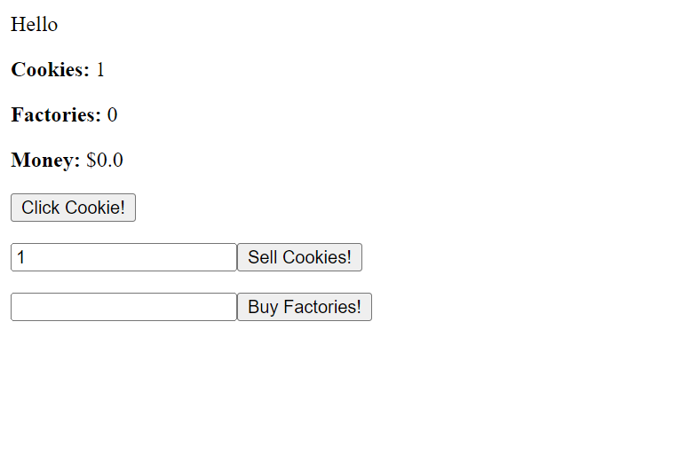  
  
  
BUG 2- Customer is redirected to the next page by  clicking the 'Start!' button with an empty name input (BUG)

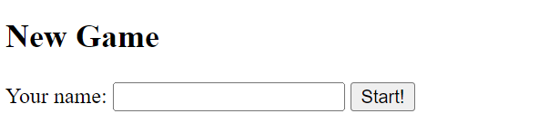

BUG 3- Error message is not shown for invalid name input / Invalid entry input is allowed(BUG)

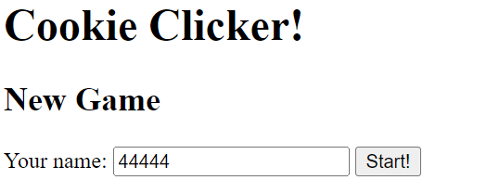  
BUG 4- Error message is not shown for invalid input(alphabet,special characters) for 'Sell Cookies!' input tab(BUG)

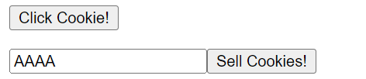  
BUG 5- Error message is not shown for invalid input(alphabet,special characters) for 'Buy Factories!' input tab(BUG)

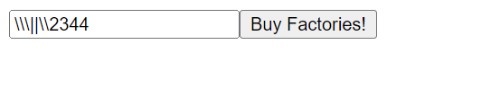  
  
BUG 6-Buy Factories is not consistent on click of button- cookies go up from 4 to 13 to 60 - need to understand from BA, product owner point of view how it is to function in a user story